**MODULE: 1**

**SE – Overview of IT Industry**

1. **What is software? What is software engineering?**

* Software refers to the programs and other operating information used by a computer.
* Unlike hardware, which is the physical components of a computer system, software is intangible and consists of instructions, data, or applications used to operate computers and execute specific tasks.
* Examples of software include operating systems (like Windows or macOS), application software (like Microsoft Word or Adobe Photoshop), and utility programs. Software can be custom-developed for specific tasks or commercially available for general use.

1. **Explain types of software?**

* **System Software:** This includes the operating systems and all utility programs that manage computer resources at a low level. It acts as a base for application software. Examples include Windows, macOS, Linux, and drivers.
* **Application Software:** These are programs that perform specific tasks for users. They can be either general-purpose (like Microsoft Word, Excel) or specialized (like AutoCAD for design, Adobe Photoshop for graphics).
* **Middleware:** This software acts as a bridge between system software and application software. It helps manage and mediate interactions between different software applications or between software and hardware.
* **Programming Software:** These are tools used by developers to create, debug, maintain, or support other programs and applications. This includes compilers, interpreters, linkers, debuggers, and text editors.
* **Open Source Software:** This software comes with source code that can be modified or enhanced by anyone. Examples include the Apache HTTP Server, the e-commerce platform osCommerce, internet browsers like Mozilla Firefox and Chromium.

1. **What is SDLC? Explain each phase of SDLC?**

* Software Development Life Cycle is a process used by the software industry to design, develop, and test high-quality software.
* The SDLC aims to produce a high-quality software product that meets or exceeds customer expectations, reaches completion within times and cost estimates, and is efficient and bug-free.

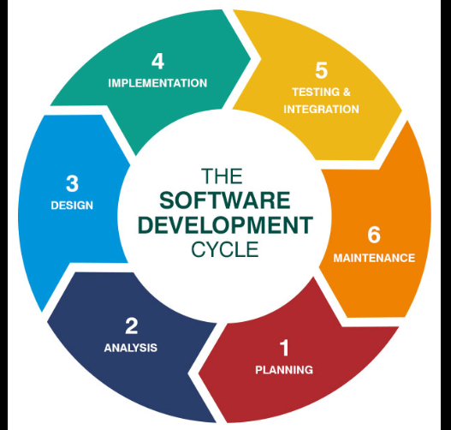

* **The main phases of the SDLC include:**

**1. Requirement Analysis:** This is the first step where end-user requirements are analyzed and documented. It involves gathering business and system requirements to understand what the software should do.

**2. Design:** In this phase, the software's architecture and design are formulated. Designers define the architecture, components, modules, interface, and data to satisfy specified requirements.

**3. Implementation (or Coding):** Here, the actual development of the software's code takes place. The design is translated into source code by the developers.

**4. Testing:** In this phase, the software is tested to find and fix bugs. It ensures that the software works as expected and meets all the requirements defined in the requirements analysis phase.

**5. Deployment:** After successful testing, the software product is delivered or deployed to the customer for their use.

**6. Maintenance:** This is the final phase, where the software is maintained and upgraded from time to time to adapt to changes. Maintenance can include fixing bugs, adding new features, or enhancing existing ones.

1. **What is DFD? Create a DFD diagram on Flipkart.**

* "DFD" stands for "Data Flow Diagram."
* It's a graphical representation used by systems analysts to depict the flow of data through a system.
* This includes data inputs and outputs, data stores, and the various subprocesses the data moves through.
* **Library Management System DFD Diagram:**
* **0 level DFD:** when a student request for a book.

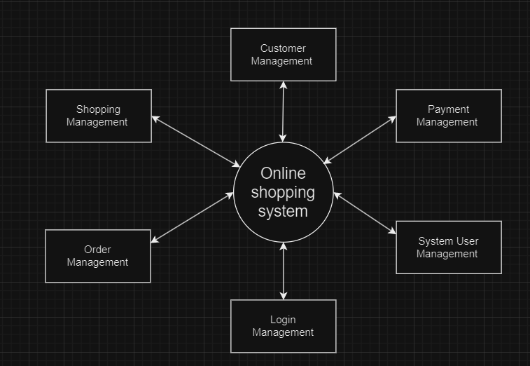

* **1 level DFD:**  At this level, the system has to show or exposed with more detail of processing.

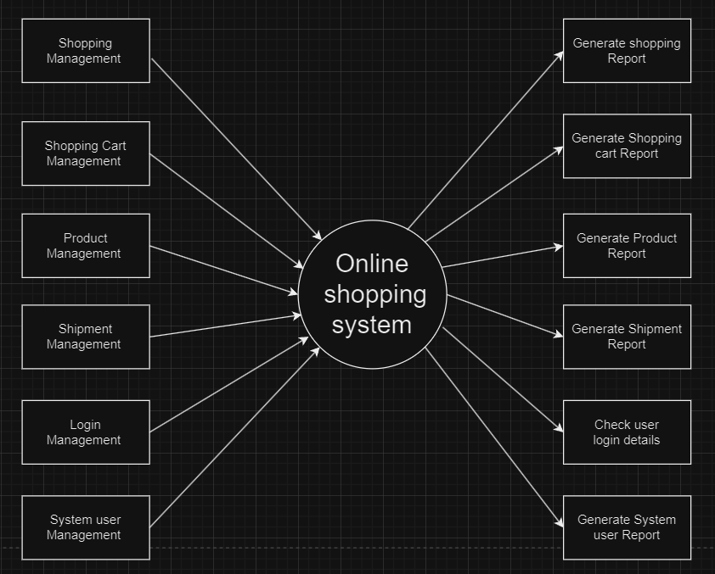

* **2 level DFD:**

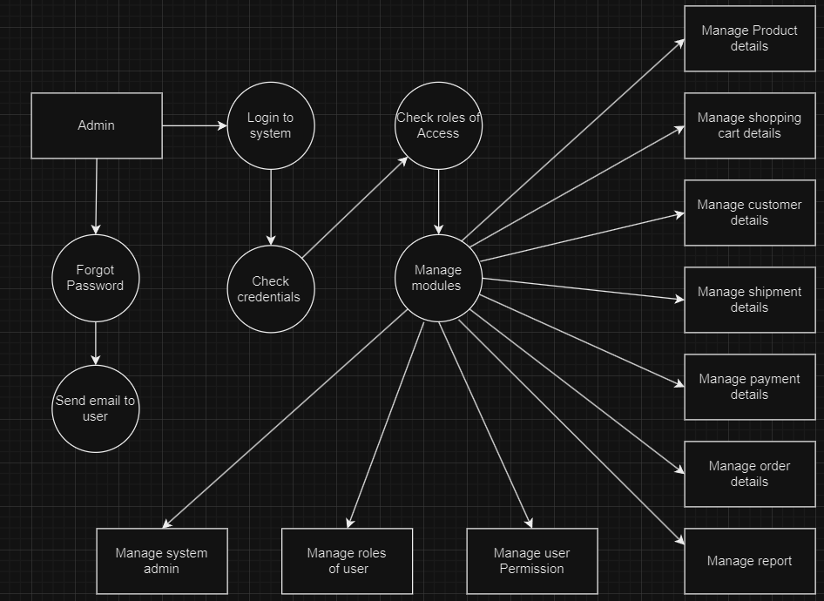

1. **What is Flow chart? Create a flowchart to make addition of two numbers.**

* A flowchart is a diagrammatic representation that illustrates the sequence of operations to be performed to achieve a specific task or solve a problem.
* It uses standardized symbols to describe the steps, decisions, and the flow of control from start to finish.
* Flowcharts are widely used in analyzing, designing, documenting, or managing processes or programs in various fields.

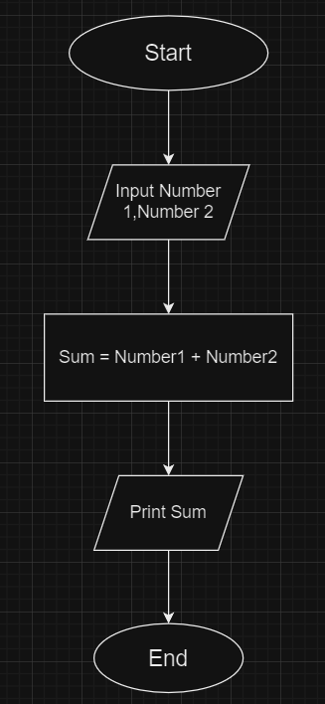

1. **What is Use case Diagram? Create a use-case on bill payment on paytm.**

* A use case diagram is a visual representation within the Unified Modeling Language (UML) that displays the relationship between actors (users or any external systems) and their interactions with a system to achieve a goal.

